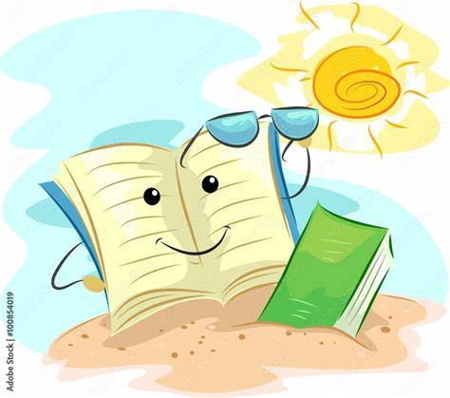
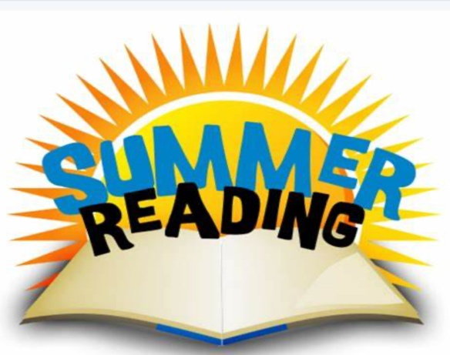
Summer Reading Project
Task 1: Answer the following 10 questions about the book that you have read. These questions will show that you have understood the book and will show that you are thinking about what the message of the book is.

- Who is the main character in the story, and what is their goal or challenge?
_______________________________________________________________________________________________________________________________________________________________________________________________________________

- What is the setting of the story? Describe it using clues from the text. Setting is where the story takes place and when the story happens.
_______________________________________________________________________________________________________________________________________________________________________________________________________________

- Name two important events that happen in the middle of the story. Why are they important?
_______________________________________________________________________________________________________________________________________________________________________________________________________________
- What dangers or obstacles does the main character face? An obstacle is something that makes it hard for a character to get what they want.
_______________________________________________________________________________________________________________________________________________________________________________________________________________
- How does the author show what the character is feeling? Give an example.
_______________________________________________________________________________________________________________________________________________________________________________________________________________
- Is there a friend or helper in the story? How do they help the main character?
_______________________________________________________________________________________________________________________________________________________________________________________________________________

- What would you say is the main problem (or conflict) in the story?
_______________________________________________________________________________________________________________________________________________________________________________________________________________
- How is the problem solved (or is it solved)?
_______________________________________________________________________________________________________________________________________________________________________________________________________________
- Find a sentence in the text that creates a strong image in your mind. Why did it stand out?
_______________________________________________________________________________________________________________________________________________________________________________________________________________
- What do you think is the message or lesson of the story?
_______________________________________________________________________________________________________________________________________________________________________________________________________________
The next 5 questions are more difficult – you only have to try to answer them if you feel confident.
- If you could change one part of the story, what would you change, and why?
_______________________________________________________________________________________________________________________________________________________________________________________________________________
- How does the main character change from the beginning to the end?
_______________________________________________________________________________________________________________________________________________________________________________________________________________
- What clues does the author give about what might happen next? (Look for hints or foreshadowing.)
_______________________________________________________________________________________________________________________________________________________________________________________________________________
- How would you describe the mood of the story — for example, is it tense, sad, exciting, or hopeful? What words make you think that?
_______________________________________________________________________________________________________________________________________________________________________________________________________________
- If you were in the main character’s place, what would you have done differently?
_______________________________________________________________________________________________________________________________________________________________________________________________________________

Task 2: Write a review of the book you have read that will encourage other Year 7 pupils to read it. Use the bullet point list below to help you and complete the sentence starters.
✅ The title and author of the book
- Sentence starter:
👉 The book I am reviewing is called _____________________ by _____________________________

✅ A short summary of what happens (without giving away the ending)
- Sentence starter:
👉 This story is about _______________________________________________________________________________________________________________________________________________________________________________________________________________
👉 It takes place in _______________________and follows the adventure of _____________________________________________________________

✅ What you liked about the book
- Sentence starter:
👉 One thing I really enjoyed was… _______________________________________________________________________________________________________________________________________________________________________________________________________________

✅ Your thoughts on the characters or setting
- Sentence starter:
👉 My favourite character was _____________________because _______________________________________________________________________________________________________________________________________________________________________________________________________________
👉 The setting was interesting because _______________________________________________________________________________________________________________________________________________________________________________________________________________

✅ Who you would recommend the book to and why
- Sentence starter:
👉 I think this book would be good for people who like __________________________________________________________________________________________________________________________________________
👉 I would recommend this book to __________________ because __________________________________________________________________________________________________________________________________________

Task 3:
Create a piece of art based on the book you have read. This could be a drawing of the setting or the main character, you could create a front cover for the book or you can draw a poster that advertises the book. Use the blank page at the back of this booklet or your own paper.

Task 4:
Take a picture of something that reminds you of the book you read. It could be a place, an object, or something that makes you think about the story or the characters.

